Kayla Bird
EDSP 4319
Spring 2017
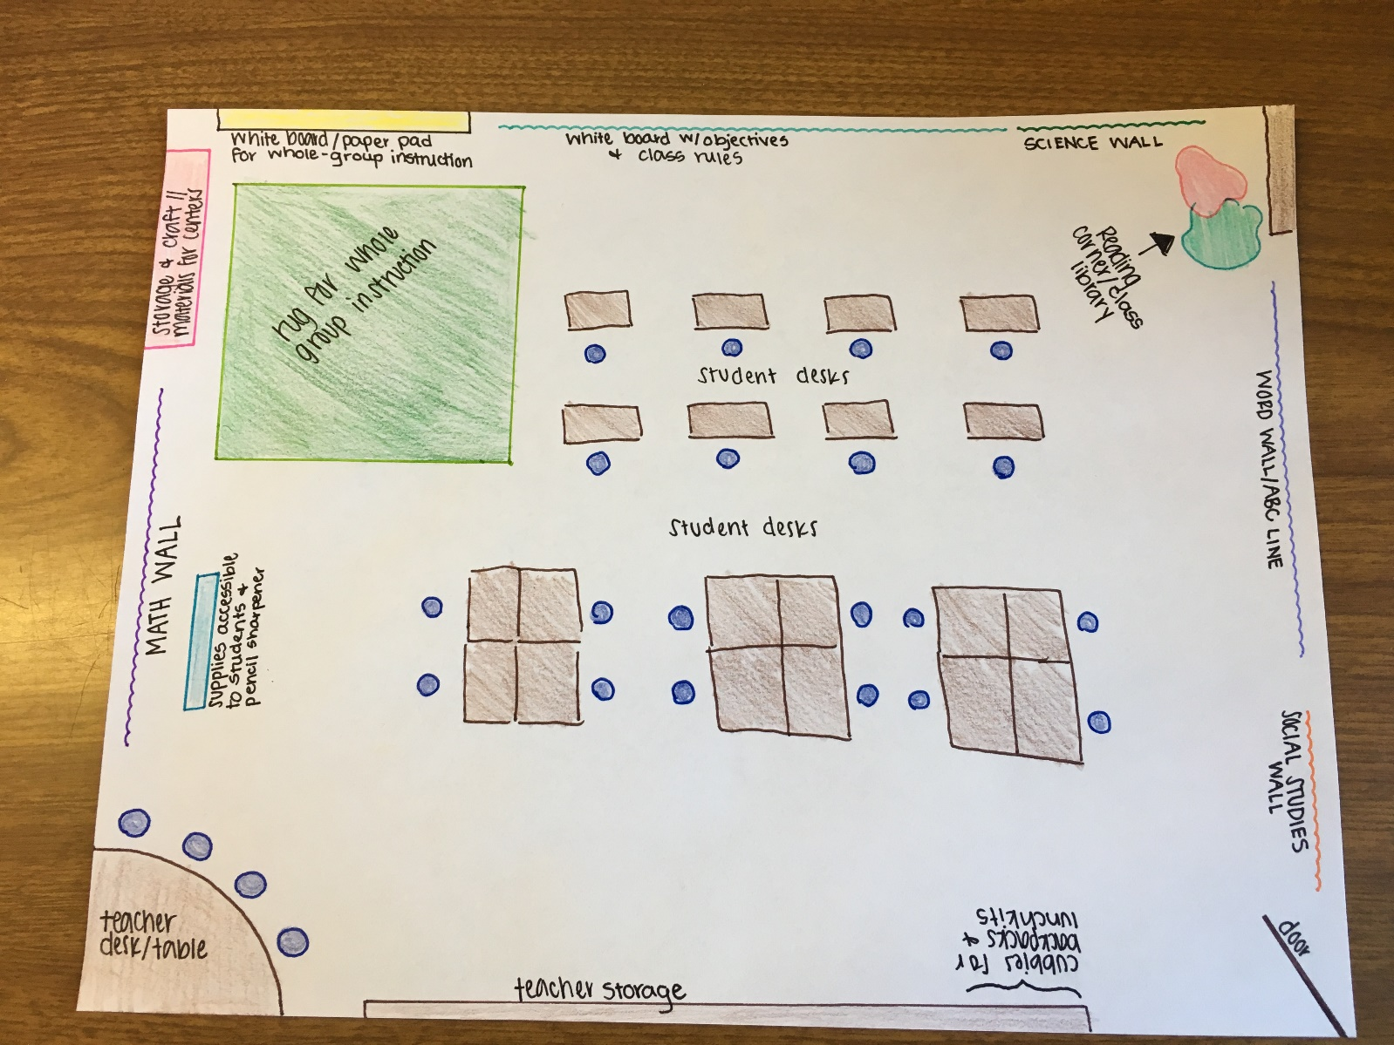

Class Schedule:
7:45-8:15—Arrival, put away backpacks and lunch kits, sit at desk
8:15-8:30—Interesting facts, objectives, announcements
8:30-9:00—Calendar time and weather
9:00-9:15—Restroom and water break
9:15-9:40—Story time and give language arts assignment
9:40-9:45—Line up for specials
9:50-10:30—Specials (art, music, PE, computer labs)
10:30-10:35—Arrive back in classroom and restate language arts assignment instructions
10:35-11:05—Students complete language arts assignments or centers
11:05-11:15—Line up, get lunch kits, go to cafeteria
11:15-11:45—Eat lunch
11:50-12:25—Recess
12:25-12:35—Restroom and water break
12:40-1:25—Math lesson and math assignment
1:25-2:00—Social studies lesson and assignment
2:00-2:05—Brain break
2:05-2:45—Science Lesson
2:45-3:00—Clean up, pack bags, make final announcements
3:00-3:15—Dismissal

Rotation signal:
In order to let students know it is time to rotate to the next part of the day, I will ring a small bell for a one minute warning and then I will ring it a second time to get their attention and verbally let them know that we are switching activities.

